# Lab: JavaScript for Front-End

Problems for exercises and homework for the "[JavaScript Applications" course @ SoftUni](https://softuni.bg/courses/js-apps)

## JS Core Module

Create a **single page** that contains a heading and 3 courses:

* **JS Essentials, JS Advanced** and **JS Applications**

**Each of them** should have a **[Details]** button. The page should look like this:

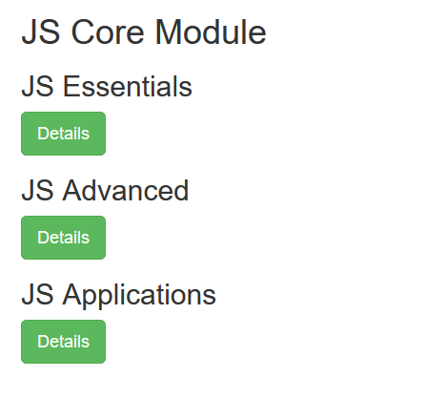

## Structure

The **[Details]** buttons should **trigger a collapse**. After **clicking** any of them you should see something like in the picture below. You can use information about course's details from: <https://softuni.bg/modules/60/js-core>

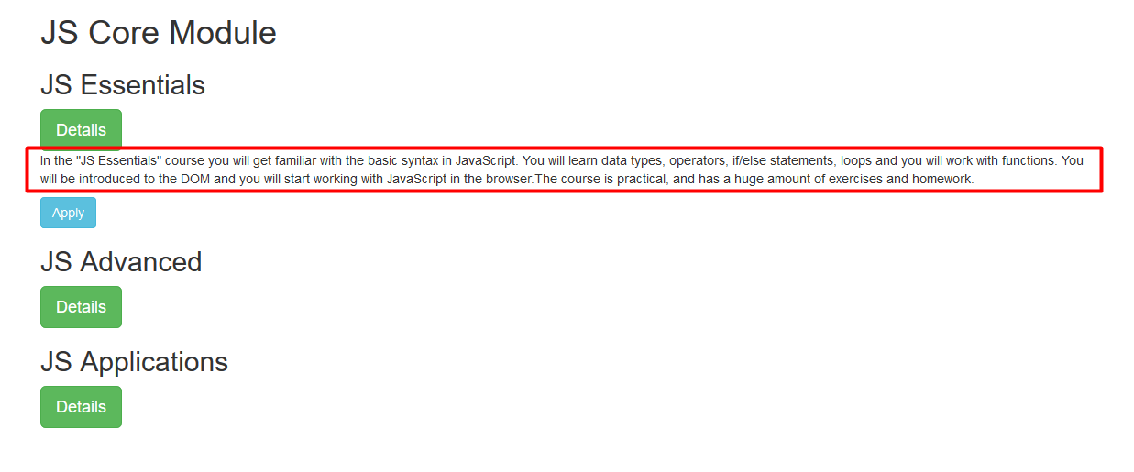

Each **"collapse"** should have a button **[Apply]**. When clicking it a **"modal"** should be displayed. It should look like this:

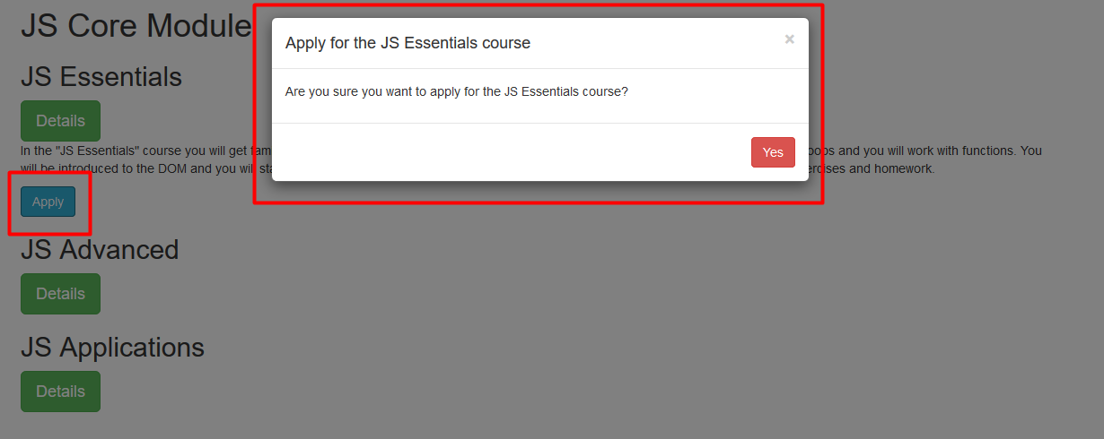

## Carousel

At the end of the page create a carousel with some **pictures** and **text**. Make **3 pages**.

* The **first** **slide/page** of the carousel should look like this:



You can use the given **pictures** from the resources and the following **text**:  
 "**JavaScript Essentials"  
 "Apply now at** [**SoftUni**](https://softuni.bg)**"**

* The **second** **slide/page** of the carousel should look like this:

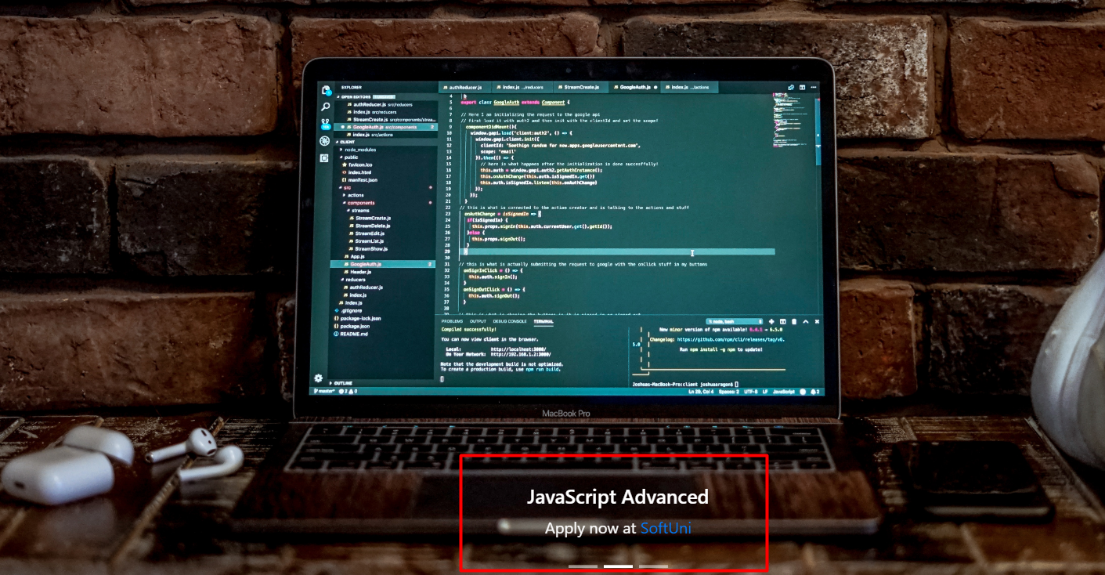

You can use the given **pictures** from the resources and the following **text**:  
 "**JavaScript Advanced"  
 "Apply now at** [**SoftUni**](https://softuni.bg)**"**

* The **third** **slide/page** of the carousel should look like this:



You can use the given **pictures** from the resources and the following **text**:  
 "**JavaScript Applications"  
 "Apply now at** [**SoftUni**](https://softuni.bg)**"**

### Hints

* Include the following links and scripts in your document:
  + <https://maxcdn.bootstrapcdn.com/bootstrap/3.4.0/css/bootstrap.min.css>
  + <https://ajax.googleapis.com/ajax/libs/jquery/3.3.1/jquery.min.js>
  + <https://maxcdn.bootstrapcdn.com/bootstrap/3.4.0/js/bootstrap.min.js>
* Use bootstrap classes for the styles
* Use the attributes "data-toggle" and "data-target" and add "id" attributes to your elements